Vermont Federation of Families for Children’s Mental Health

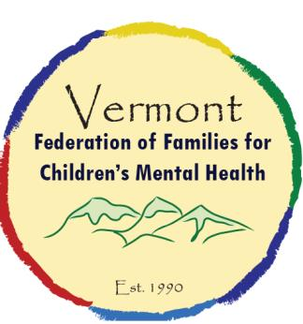
Children’s Mental Health Day Mini Grants offered in 2018
  - Children’s Mental Health Week May 7th- 13th, 2018

VFFCMH is offering 6 regional mini grants in the amount of $250.00 for planning a Children’s Mental Health Day events across Vermont!

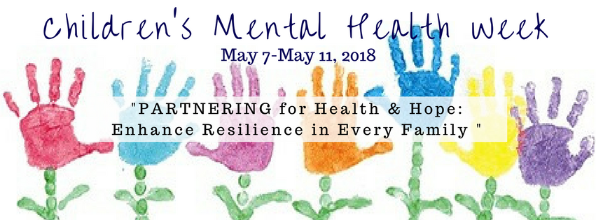
What are you planning for an awareness event this year? Are you planning to join us and more than 1,100 communities across the country in celebrating the Substance Abuse and Mental Health Services Administration’s (SAMHSA) National Children’s Mental Health Awareness Day to highlight the importance of positive mental health from birth? This year, the national focus of Awareness Day is “Partnering for Health and Hope Following Trauma”. Partnering for Health and Hope Following Trauma will focus on the importance of an integrated approach to caring for the mental health needs of children, youth, and young adults who have experienced trauma, as well as their families. VFFCMH’s would like to invite you to request a mini grant from us to plan an event this year. Our theme this year builds off the national theme which includes collaborative efforts in increasing resiliency in every Vermont family:
To celebrate Awareness Day, The Federation of Families for Children’s Mental Health, VFFCMH, is hosting a resource and information table in two locations:

On Church Street Marketplace in Burlington
&
The Agency of Human Services Lobby in Waterbury.
For over 25 years, The Vermont Federation of Families has supported families of young children, youth, and young adults with emotional, behavioral, or mental health challenges in Vermont to find the services and supports they need to meet their goals at home, school, and in the community. The Vermont Federation of Families is nonprofit organization of parents and youth with lived experience.
Awareness Day is an opportunity to celebrate the positive impact that we can have on the lives of children, youth, and young adults when we are able to integrate positive mental health into every environment. When we focus on building resilience and social-emotional skills in young children from birth, we can help young children, youth, and their families thrive."
“Data indicates about 1 in 5 American children suffer from a diagnosable mental illness during a given year, and nearly 5 million American children and adolescents suffer from a serious mental illness (one that significantly interferes with their day-to-day life). Mental health is essential to overall health and well-being. We know that:
• Serious emotional and mental health disorders in children and youth are real and treatable.
• Children and youth with mental health challenges and their families deserve access to services and supports that are family-driven, youth-guided and culturally appropriate.
• Values of acceptance, dignity, and social inclusion should be promoted throughout all communities for children, youth, and families.
• Family and youth voice is a valued asset in determining appropriate services and interventions”

Children’s Mental Health Awareness Week Mini Grants - $250.00
ONLY SIX Available
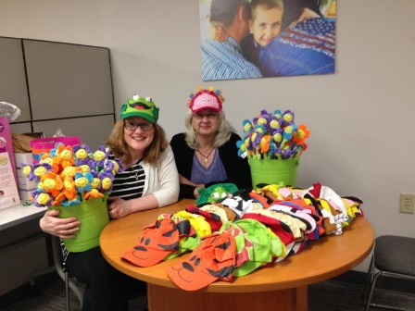
The Vermont Federation of Families for Children’s Mental Health (VFFCMH) is issuing a request for proposal (RFP), for planning and awareness events across Vermont. The activities can range from positive social opportunities and community organizing to mental health awareness campaigns. Our goal is to assist and empower children youth and young adults along with our communities to use their voice of experience to positively impact the system of care and their communities while strengthening their self-advocacy skills and mutual support. When we talk about Mental Health and Mental Wellness we reduce stigma.
What’s the Process?
- Applications accepted starting March 15th 2018. Application deadline is April 5th, 2018. All projects and activities must happen and be complete by May 30, 2018. The proposal should contain the “who, what, when, where and how” of the project/campaign/event(s), and a proposed budget of what resources will be needed, approximate prices, purpose of the purchase and in-kind contributions.
- The proposal will be considered for funding by a team of VFFCMH staff.
- The funds will be awarded limited to 6 regions, checks will be processed and mailed by April 10th.

Other Information
- Compensation checks will be written to organizations not individuals – Please include who the check should be written to and the address to send it.
- We encourage area organizations who support and empower children, youth, and young adults to work together, as there will only be one application approved per region. These are competitive as we only have 6 grants to offer, so get your applications in early.
- May is Children’s Mental Health Month, so we also encourage you to consider scheduling your activities to happen in May. It would be great to be able to advertise “May is Mental Health Month” and have regional activities for folks to plug into all over Vermont.
- An evaluation of the project must be completed at the end of the project
- All project messages need to be positive and align with the National Children’s Mental Health Awareness Week theme or the Vermont Federations Children’s Mental Health Awareness Week theme.
- This funding can be combined with other resources and funding
- Applications can be submitted online or by mail
- Projects are prioritized when planned during Children’s Mental Health Week May 7-11, 2018 and /or must be completed by May 30, 2018 indicating this event was in accordance of May as Mental Health Awareness Month.

Please submit all applications to:
Cindy Tabor, ctabor@vffcmh.org
Or mailed to:
The Vermont Federation of Families for Children’s Mental Health
P.O. Box 1577, Williston VT 05495
Phone: (800) 639-6071ar

Children’s Mental Health Awareness Day, Week and Month Mini Grant Application 2018

Region:
Project contact person:
Name:
Phone Number:
Mailing Address:
Email address:

Project Description
Describe the project providing information on how it will be implemented and who you are partnering with to accomplish the project.

Objectives
Describe the project objectives. What do you hope to accomplish through this project?

Dates of Activities (to be completed by May 30, 2016)

Make check out to: (Name and Address of the Organization)

Sample Budget
Item | Cost | How Many | Total | In Kind
Totals
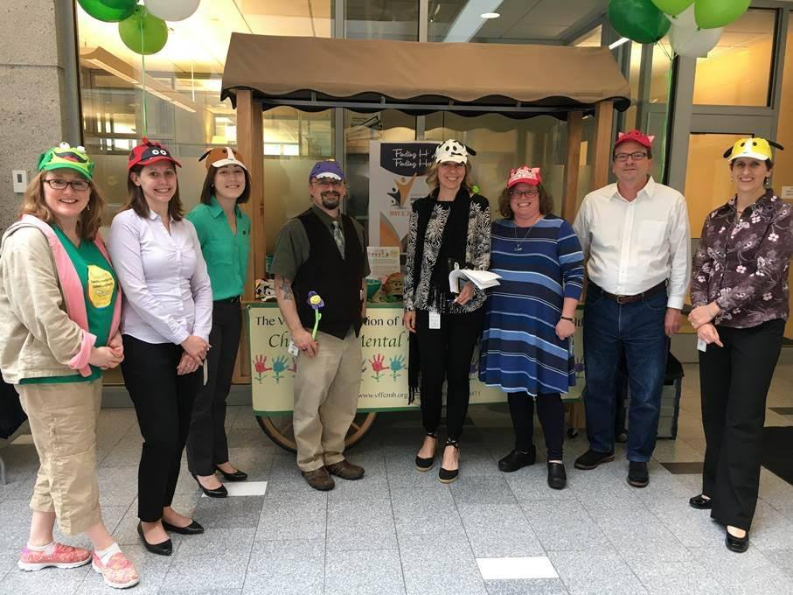
an

